**Lab 05 – Lê Minh Nghĩa - 20225894**

1. Swing Components

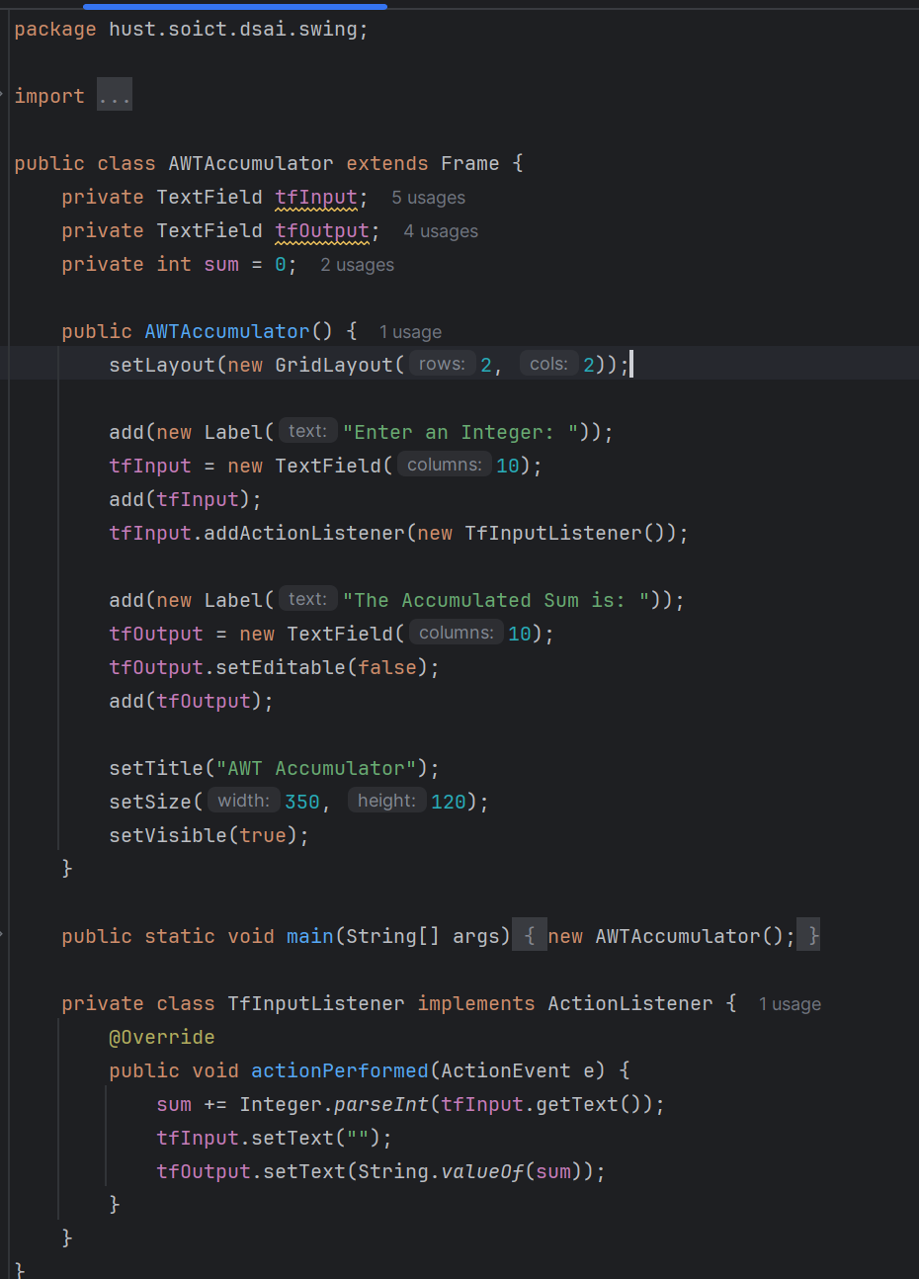

1. Organizing Swing components with Layout Managers

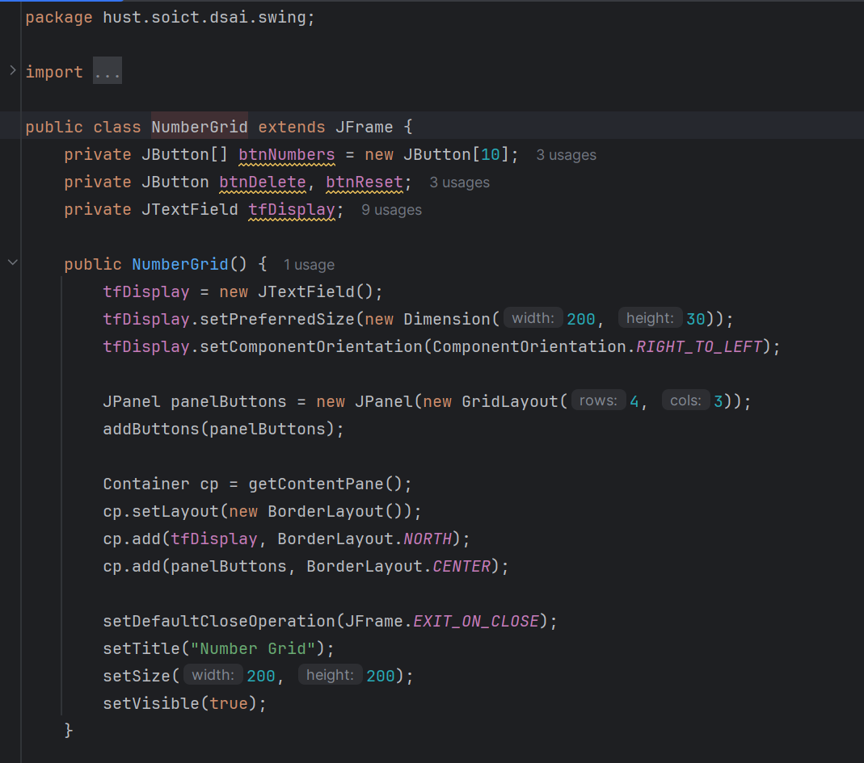

1. JavaFX API – GUIProject

1. JavaFX API – AimsProject

StoreScreen.java

MediaStore.java

CastScreenController.java

CartScreen.java

AdditemToStoreScreen.java

AddCompactDiscToStoreScreen.java

AddBookToStoreScreen.java

TestMediaEquals.java

Exception

